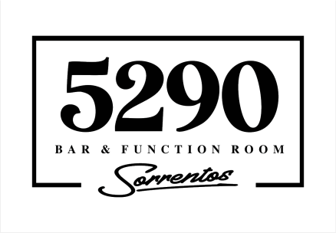
PLATTERS MENU

Our range of platters can cater for any occasion, from light morning teas & lunches, to late night cocktail parties. Got specific dietary needs? Let us know upon booking and we’ll be happy to assist you in your platter selections

Breakfast & Morning Tea
Muesli Cups $40
Granola style muesli, fresh Fruit, & coconut yogurt (GF, Vegan)

Mini Mixed Muffins $80
A selection of mini muffins (GF)

Scones $55
Fresh scones, topped with jam and whipped cream (savoury cheese & chive scones also available)

Fresh Fruit Platter $55
A selection of fresh cut seasonal fruits (GF, Vegan)

Toasted Banana Bread $55
Our gluten free banana bread, toasted and served with butter

Egg & Bacon Sliders $75
Fresh slider buns filled with; omelette style egg, bacon, cheese & our BBQ sauce

Light Lunch
Fresh Sandwiches & wraps $75
A selection of fresh made sandwiches (includes vegan option)

Toasted Focaccias $75
A selection of our famous toasted focaccias

Mini Bruschetta $50
Toasted croutons topped with; hommus, tomatoes & balsamic glaze (Vegan)
Or; beetroot tzatziki, comfit mushrooms & crumbled fetta
Or; avocado, smoked salmon, & capers (+$15 per platter)
Dinner/Late Night Cocktail
Brewers Board $90
A selection of cured meats, cheeses, dips and crackers (GF option available)

Trio of Dips $55
A selection of dips served with our garlic flat bread (GF option available)

Portugese Chicken Skewers $60
Char grilled and served with house made Tzatziki (GF)
(Prawn skewers available +$10 per platter)

Arancici Balls $75
Our famous pepperoni parmesan & herb risotto balls, served with sundried tomato aioli
(Vegetarian option available)

Buffalo Wings $65
Dry rubbed wingettes, char grilled & tossed in our BBQ sauce, served with garlic aioli

Salt & Pepper Squid $70
Pieces of calamari, fried in a seasoned batter, served with tartare sauce

Sliders $75
Fresh slider rolls, filled with lettuce; char grilled steak & dijon butter
Or; char grilled chicken and garlic yogurt

Bakers Basket $140
A selection of assorted savoury pastries with dipping sauce

Fried Finger Foods $120
A selection of cocktail finger foods, served with tomato aioli

Gourmet Pizza
Our full selection of Sorrentos pizza are available (see menu for options & prices)

If there’s something specific you’re after for your event? Oyster, Petite Fours, Soup Shots, etc? Please let us know, and we can arrange a custom menu for your event

After a sit down meal instead? We can also offer a variety of set menu options or our full Sorrentos Cafe main menu for a private dinner party

